Notes:

- Supply a screenshot of your GNS3 window with a simple topology as shown in step 25 above. You should save your project as “Lab 1-<SMU Student ID>. (where <SMU Student ID> is your student ID).
- Supply a screenshot of your Wireshark capture as shown above in Step 27, and save the PCAP as “Lab 1<Student ID> as well.
- What other traffic other than the ping do you see in the Wireshark Capture?
- What kinds of patterns do you see in the traffic? How much time passes between traffic types?
- Lab Report
In this initial lab we were asked to install and configure a virtual routing software known as GNS3. We were also asked to install a protocol analyzer known as Wireshark. A specific network configuration was also supplied in order to establish that the GNS3 software was successfully deployed. We were also instructed to perform a sample protocol analysis with Wireshark. This too was to establish a baseline that Wireshark is working as needed.

For my lab environment I chose to create a virtual machine on my Synology 1522+ Network Attached Storage. After creating a Microsoft Student Account I was able to download a Microsoft Windows 10 ISO, Win10_22H2_English_x64v1.iso, and use it to build my VM, or virtual machine. After creating a container with 4 cores, 8 gigabytes of RAM and 500 gigabytes of hard drive space, I deployed the Windows 10 ISO. Once the build was complete, I was able to power on and login to the Microsoft Windows VM. Here is a screenshot of the Virtual Machine Manager:

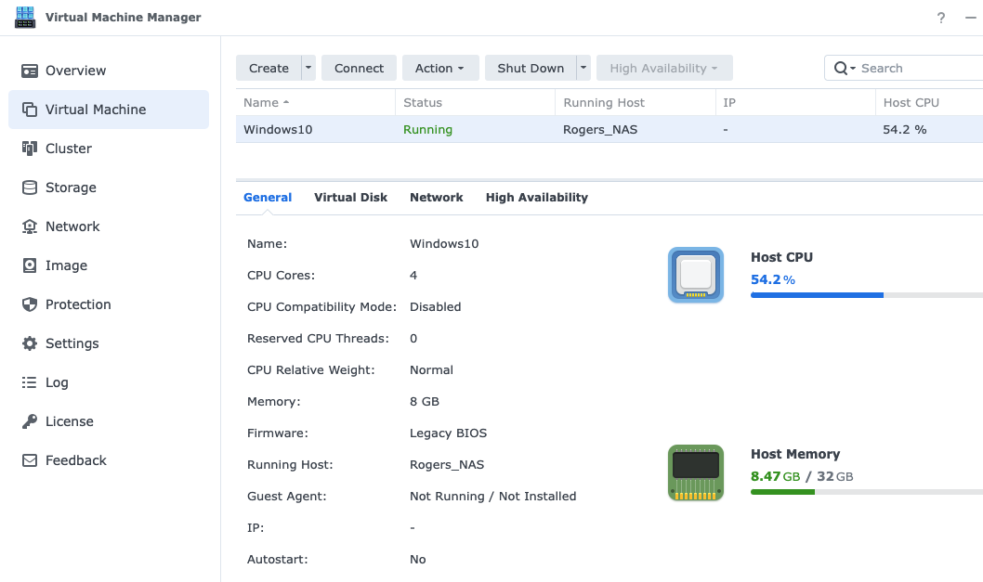

Once I was logged onto the Microsoft Windows 10 VM, I began the process of downloaded the GNS3 software as described in the lab 1 instructions. After completing the install of GNS3 and Wireshark, I began the configuration of the Lab 1 Network.

PC1 Ip 192.168.1.10/24 192.168.1.1
PC2 IP 192.168.2.10/24 192.168.2.1
R1 int fa0/0 Ip address 192.168.1.1 255.255.255.0
Int fa1/0 Ip address 192.168.3.1 255.255.255.0
Rip v2 Network 192.168.1.0, 192.168.3.0
R2 Int fa0/0 Ip address 192.168.2.1 255.255.255.0
Int fa1/0 Ip address 192.168.3.2 255.255.255.0
Rip v2 Network 192.168.2.0, 192.168.3.0

Here is a screen capture of the GNS3 Virtual Network:
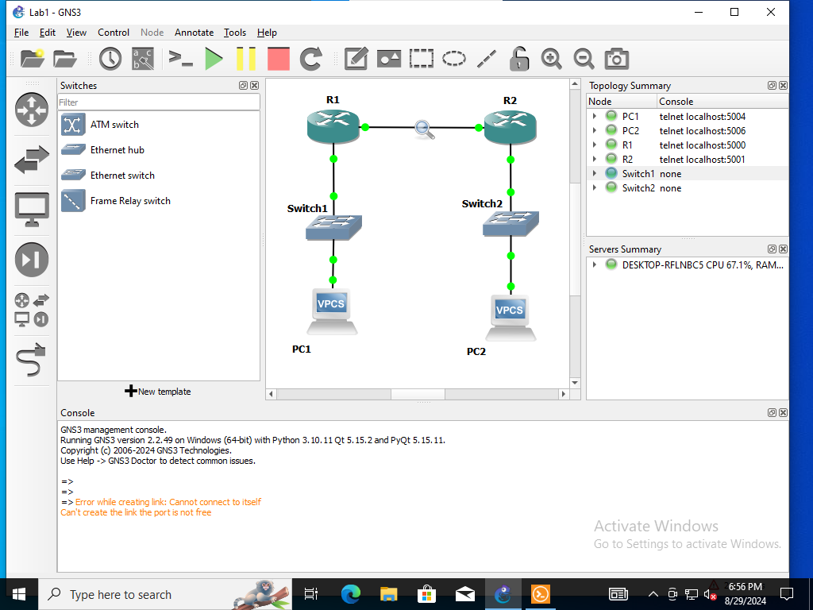
Once I was successfully able to verify end to end connectivity from PC1 to PC2, I turned on a continuous ping in order to capture IP traffic via Wireshark.

After watching the protocol packet analysis, I was able to note that many system level protocols were active, including:
- ARP: Address Resolution Protocol
- CDP: Cisco Discovery Protocol
- ICMP: Also referred to as a “ping” which included “echo reply” and “echo request” packets.
Every protocol has standards-based requirements and these statutory requirements determine when and how often these protocol packets are sent. The time ranges from one or more milliseconds to hundreds or thousands of milliseconds.
I have concluded that the GNS3 virtual network environment and the Wireshark Protocol Analyzer were successfully deployed and ready for further exploitation.
Here is a screen capture of Wireshark:
